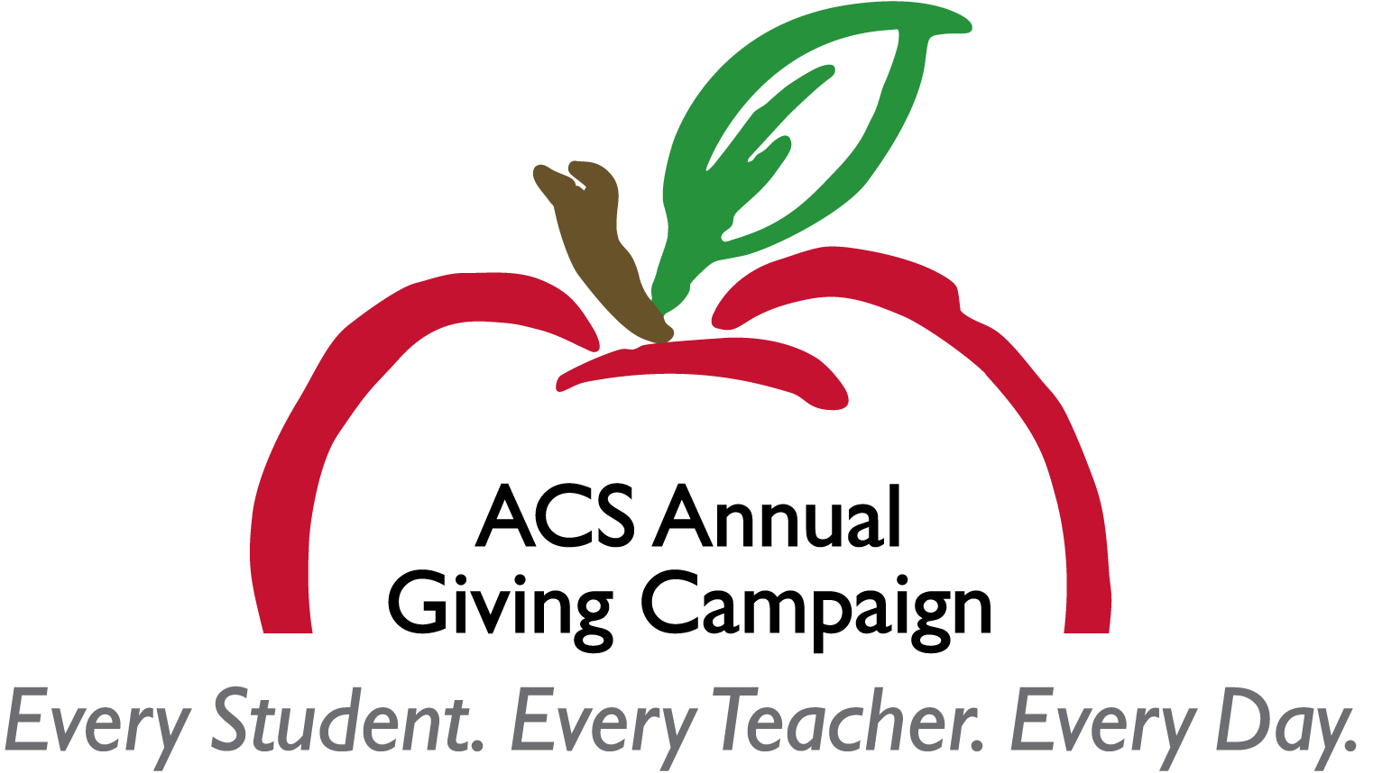

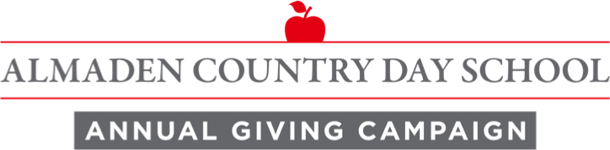

2018-2019

VOLUNTEER HANDBOOK

TABLE OF CONTENTS

- Important Dates ……………………………………… 3

- Team Member Job Description……………………………... 3

- AGC 101………………………………………………….… 4

- General Information and Procedures…………………..…… 5

- Using the Google Doc………………………………………. 6

- Phone Call Advice………………………………………..….. 7

- Sample Emails…………………………………………..…… 8

- Frequently Asked Questions…………………………………. 10

- Donor Appeal Letter………………………………………… 16

- Infographic………………………………………………….... 17

IMPORTANT DATES

Friday, 10/5 Campaign Kick Off

10/15-10/26 Make Initial Contact With Prospects

10/29-11/2 Follow Up With Contacts to Secure Participation

11/5-11/9 Make Last Attempts to Secure Participation
(Note: Administration will reach out to those who gave $1k or more in the prior campaign if they have not yet committed.)

Friday, 11/9 Campaign Officially Ends

TEAM MEMBER JOB DESCRIPTION

Function: To broaden the donor base of financial support to ACDS by soliciting funds from individuals during the Annual Giving Campaign and promoting the case for support amongst the parent community.
Responsibilities:
- Make a gift to the Annual Giving Campaign.
- Promote the Annual Giving Campaign to other parents.
- Make personal contact with ~10 assigned donors through personal, face-to-face solicitation, phone calls or personal notes.
- Maintain accuracy and confidentiality of donor information by recording comments and responses from conversations with donors.
- Update AGC Google Doc with prospect’s intent to participate.

AGC 101

ACDS’s Annual Giving Campaign is the foundation on which the Almaden Country Day School development program is built.

Purpose
The Annual Giving Campaign serves several purposes:
- Directly benefits school programs in the year in which they are given
- Assists in securing the best educators for the school
- Provides opportunities for professional development for faculty
- Builds a community of philanthropy
- Develops and strengthens relationships between parents
- Serves as a prelude to future major funding projects

Benefits of Giving
The basic reasons for giving to the annual fund include:
- To bridge the difference between tuition revenue and the cost of education at ACDS
- To provide the opportunity to see giving directly benefit all students
- Displays community cohesiveness. When ACDS applies for accreditations (i.e. CAIS), grants or foundation support, these institutions want to see that the parent community is committed to the school. One key way they measure that is through Annual Giving participation.
- Contributions are tax deductible as provided by law.
- There are psychological benefits of giving that are often prime factors in the success of an Annual Giving Campaign. The non-monetary benefits of giving can include:
- Involvement with and confidence in the school
- Show of appreciation for the school and its faculty
- Sense of ownership in and partnership with the school

Benefits to the School
In addition to the dollars raised, the school can benefit in other ways from the Annual Fund:
  - Opportunity to provide students and teachers with resources inside and outside of the classroom
  - Opportunity for ACDS Administration to develop a sound financial plan for the school year

GENERAL INFO AND PROCEDURES

The Annual Giving Campaign runs from October 5th through November 9th with pledge payments due by the end of the school year, or May 31th.
All AGC donations are credited according to the receipt date and are tax-deductible as provided by law.
Step 1. Preparation
- Review Annual Fund Materials including the FAQ at the end of this handbook.
- Review prospect forms for each family that you will be reaching out to throughout the campaign.
- Call the Development Office with any questions or if you need clarification on what the annual fund supports or how to better explain it to parents.
- Take the opportunity to plant the seed about giving by asking other parents if they received the mailing or seen the video and apple seed messages yet.
- Record feedback you hear from parents or your own personal thoughts on the communication pieces or messaging. Send Development Office any relevant feedback you have heard from parents.

Step 2. Action
  - Prior to making calls, make your own gift or pledge to the campaign
  - During the week following 10/15, begin to make calls and/or send emails to the parents on your list (see sample emails and phone advice in this handbook), asking for them to join you in making a gift to the campaign. Try to use as much face-to-face interaction as possible. Encourage participation at all levels!
  - Follow up with all prospects with a goal of getting a “yes” or “no” answer from them prior to the close of the campaign.
  - Please make sure to ask if the donor’s company has a matching gift program. All matching gift companies can be found on ACDS’s website.
  - If families have questions or concerns beyond your ability to answer, ask if it would be ok to pass along their thoughts to Jenn Hull, Jennifer Glasser or Ole Jorgenson and have one of the Administrators call them to provide the answers they seek.

USING THE AGC GOOGLE DOC

Purpose: To allow ACDS and AGC callers to efficiently record caller communication and update gifts.
When a gift is made to ACDS, we will update the Google doc ASAP.
Please make sure to check your Google doc before reaching out to a prospect.
*Note that sometimes there is a short lag between the donor making a gift and ACDS receiving notification and updating the doc. This is especially true for those who make their gifts through their workplace giving portal. ACDS isn’t made aware of those gifts for 4-6 weeks.

Tips on using the doc
“Employer”
· We include this information so the callers can inquire about matching gifts. While not required, callers may choose to browse our website to see if their company matches.
· Please keep in mind that the employer listed may not be current. Families are asked to update this information annually, but they may not. If you learn someone works at a different company, please make a note of it so ACDS can make the change in our database.
“Notes Field”
Please use this field to keep track of when you communicate with your prospect, if they intend to make a gift, and enter any important information the school should know.

PHONE CALL ADVICE

The most important thing during a phone call is to feel comfortable and use your own words to connect with your prospective donor. You may choose to send an introductory email before placing a phone call to your prospective donor. Please make sure you’ve reviewed the FAQ’s on AGC prior to making your call.

Below is a sample template of a potential conversation.

- Introduce yourself as a parent or alumni volunteer from ACDS, reference your introductory email and ask if it’s a good time to chat for a brief conversation about AGC.

- A nice way to break the ice is to ask them how the year is going for their children? You may also want to ask what grade their child is in or which teacher they have this year.

- One options is to then segue to telling the caller a little about the campaign. For example:

“As you may know this year, ACDS is trying to raise $375,000 over the next five weeks to help bridge the gap between what we pay in tuition and what it actually costs to educate our children the ACDS way with more experiential, hands on learning.

Funds raised are used in the classroom immediately and throughout this school year for all the programs our children love – music, science, drama, literature, etc.

I’m hoping you will join me in supporting this year’s Annual Giving Campaign. We are hoping that all families will participate this year. A gift of any size is welcomed and appreciated. We hope that you’ll consider participating at a level that is comfortable to your family. The school has suggested a gift of $1,057 per student or more will help us reach our goal. A gift of $2,000 or more is recognized as a leadership gift. Can we count on your support this year?”

If they say yes, you can respond with “Great! Can I send you the link to make your gift or pledge online or you can send in the pledge card you received in the mail.”

- Please make sure to mention if they make a gift, we can check to see if their company provides a matching gift opportunity.

If the prospect isn’t interested in talking or is upset by your call, please be kind, apologize for disturbing them and thank them for their time. Always listen and do not be defensive. Further, let them know you’ll make the school aware of their preference not to be contacted by phone in the future. Please make sure to notify the Development Office of this person’s preference.
SAMPLE EMAILS

If you choose to contact your families via email, here’s a sample of a letter you could use. Feel free to use this or something similar in your own voice.
First Email - Week 1

Hello (ACDS Family),
My name is xxx and I’m the parent of x# of children here at ACDS. Last year my spouse and I enthusiastically donated to ACDS’s successful Annual Giving Campaign. This year, I found myself volunteering to follow up on the invitation in the mail to give to the campaign. I would like to personally ask you to join me in supporting the campaign to raise $375,000 for ACDS in just five weeks.
Our family gives to the campaign because we believe in ACDS, its teachers and the quality of education our children receive. We know that our tuition doesn’t cover all the educational expenses required to provide our children with the quality education they receive at ACDS.
I completely understand how everyone gets so busy this time of year with all of the demands on our time. So, over the next few weeks, I’ll be reaching out to you to answer any questions you may have and ask for your participation. If you’ve already made a decision about participating in the campaign, please feel free to make your contribution online, send in your pledge form, or drop me an email. That’s my signal that you don’t need additional contact. If you’d like, you can also call me any time before 8pm, any day of the week. Cell phone is best: xxx-xxx-xxxx or the home: xxx-xxx-xxxx
Thank you for your time and I look forward to speaking with you.
Sincerely,
Your name here
P.S. Keep in mind that gifts are tax deductible and each gift directly supports your child’s education this year!
“Nothing is more important than coming together to accomplish something that no single person can manage on his or her own.”

SAMPLE EMAILS

Second email - Week 3
Hello again!
I am pleased to share that we have raised $xxx,xxx towards the Annual Giving Campaign goal of $375,000 and we’re still over two weeks away from the campaign wrapping up! I am sending off our contribution this week.
If you have any questions please do not hesitate to give me a call during the day on my cell xxxx or at home after 7pm at xxx.
Not to be guilty of the hard sell – after all, these are our kids, but here’s a reminder of some of the rewarding reasons for giving to the Annual Giving Campaign:
- Directly benefits all school programs
- Assists in securing the best educators for the school
- Bridges the gap between tuition revenue and the cost of education
- Contributions are tax deductible
Our goal is to get as many parents to participate as possible. Hope we can count on you! If we don’t hear from you before November 5th, I’ll reach out again to see if we can connect via phone.
Sincerely,
Your name here

FREQUENTLY ASKED QUESTIONS

Reasons to Donate & Tuition Gap
What are Annual Giving funds used for and how do the funds benefit my child?
Your Annual Giving dollars are put to use in the classroom immediately and throughout the academic year. These dollars allow ACDS to provide outstanding educational enrichment programs and employ quality teachers and staff who create the nurturing educational experience our children love. Specifically, contributions allow ACDS to provide:
- Small class sizes and greater teacher contact
- Materials for hands-on curriculum for every age level
- Classroom technology integration
- Innovative academic and enrichment programs including Drama, Art, Music, Robotics, Science, Foreign Language and Physical Education
- Field trips
- Teacher professional development classes and conference attendance
- Support for day-to-day operating expenses and improved compensation for our teachers.

As a parent, I already pay tuition. Why do I need to donate money as well?
ACDS students benefit from having talented and dedicated teachers, small classes, curricular resources and outstanding enrichment and elective offerings. While the tuition that you pay gives your child access to an exceptional education, it does not cover the complete cost of his or her ACDS experience. This year, tuition revenue covers approximately 90% of the school’s total operating budget. To bridge the shortfall between the actual cost of an ACDS education and tuition, ACDS – like other independent schools – turns to parents, alumnae families and other friends of the school to bridge the gap.

Why does ACDS have a tuition gap?
- It is standard practice for Independent schools to budgeted with both earned and contributed income. The variance between tuition income and the cost to educate each child, or the “gap”, is what we’re responsible for fundraising. Keep in mind that gifts are tax deductible and tuition is not.
- Tuition covers about 90% of costs.
- ACDS’s total gap is $1,400 student, and suggesting that parents give $1,057 per student during the annual giving campaign.
- FYI - The gap at Hillbrook is ~$4,500 per student, and at St. Andrews, the annual giving ask is 10% of what they pay in tuition, or approximately $2,800 per student.

Why does the school ask for a donation on top of tuition?
- The Board and administration try to limit tuition costs by intentionally leaving a gap between what an ACDS education costs and what tuition covers. This amount must be raised each year, but unlike tuition, your charitable gift is tax deductible.
- All nonprofit independent schools in California rely on an annual campaign model like ours.

Tuition Increases
Why is tuition increasing so much? Where’s the value for the tuition increases?
- In 2008, ACDS faculty was compensated in the 13th percentile compared to 150 similar private elementary schools in Northern California. In 2016, we’ve reached the 52nd percentile.
- These improvements in compensation allowed us to keep one of our best teachers who was approached by one of the Catholic high schools; we’d eliminated the pay disparity that used to allow other schools to poach our best teachers. This popular and talented teacher chose to stay at ACDS.
- We hired seven new teachers to ACDS this year, all of whom were our top choices from among the hiring pools for their positions.
- The tuition increases have enabled ACDS to focus on improving faculty compensation so that we can attract and retain our finest teachers. In addition, ACDS is working hard to keep up with new developments and best practices in education. This year we added a dedicated Learning Support Coordinator, critical to keeping our promise of discovering the gifts in every child. We have also introduced the Reading Workshop in the elementary grades, the full implementation of Advisory in the middle school, and year three of Bridges Math (including monthly visits from the Bridges math consultant and another parent workshop). None of this would be possible without the AGC.
- The school is further committed to providing ongoing professional development and training opportunities to our faculty that constantly evolve student’s classroom experiences. We offer 15 in-service days and 3 half days to offer our teachers support for all new of these programs. Our robust professional development budget makes this possible.

Will tuition continue to increase at such a high rate next year?/In future years?
- It is safe to say tuition will increase annually. How much? We don’t know. Every year, the Trustees consider the short- and long-term financial health of the school and set tuition accordingly.
- Tuition increases among CAIS independent PK-8 schools range from 2-12%, with the average in the 5-6% range.
- It’s important to remember that the costs of doing business in Silicon Valley have increased dramatically over the years.
- ACDS creates new offerings (new math curriculum, science equipment, increased professional development for teachers, Imaginarium, etc.) to keep up with new developments and best practices in education.

How is tuition revenue used?
Tuition dollars are spent in 5 major categories:

- Curriculum and programs
- Educational technology
- Professional development

- Salaries and benefits
- Facilities

How does our tuition increase compare with other schools?
- ACDS tuition currently puts us in the 21st percentile among CAIS schools.
- Tuition increases among CAIS independent PK-8 schools range from 2-12%, with the average in the 5-6% range.

Should we be worried about the decline in enrollment?
- ACDS enrollment has moved through cycles in the past.
- We’ve known about the decline for years, and we’ve built our financial models accordingly. The birth rate dropped during the Great Recession and in the demographic serving private schools like ACDS, it has not recovered.
- Birth rates are not expected to recover until 2026. Again, the Board and administration are planning accordingly; the school has strong reserves and has already made staffing adjustments that guarantee a balanced budget but will not impact the teachers or children in any way.
- Our 5-year financial plan takes the birthrate decline into account, and ACDS will be fine. Thanks to strong fiscal planning and management over the last 9 year's, ACDS is currently in strongest financial position of the school’s history.

AGC Nuts and Bolts
Why should I consider being a Leadership Donor?
The generosity our school experiences is a result of leaders like you who know their giving has a direct impact for their children's education. You now have several levels of leadership to participate in, each level adding essential value to our school's pursuit of excellence. Each year Leadership Donors distinguish themselves by making annual gifts of $2,000 or more to Almaden Country Day School’s Annual Giving Campaign. As a Leadership Donor, the impact of your extraordinary philanthropy is evident in ACDS’s commitment to increase faculty compensation and explore new technologies and teaching materials. You will also enjoy an annual gathering with the Head of School and trustees as well as the knowledge that you are at the forefront of ACDS’s most important fundraising project, the Annual Giving Campaign.

How are Leadership Donor levels calculated?
ACDS recognizes gifts of $2,000 or more as “Leadership Donations.” Our giving levels are as follows:
$2,000 - $2,499 - Imagine
$2,500 - $4,999 - Envision
$5,000 - $9,999 - Aspire
$10,000 or more - Legacy
Leadership donations are calculated based on combination of personal donations and matching gifts. Gifts made in support of the “Raise the Paddle” project at The Mixer are included. While proceeds of items purchased at the Auction for ACDS benefit the school, they are only tax deductible to the extent they exceed the value of the item and do not count towards becoming a Leadership Donor.

What is a “Matching Gift” and how do I know if we are eligible?
Your gift can be doubled or tripled if you or your significant other works for a company with a matching gift program. It’s easy to find out if your company matches. Go to Support ACDS:Matching Gifts section of the ACDS website for a comprehensive database of matching gift companies.

How can I give and what is ACDS's Tax ID Number?
Since ACDS operates as a 501(c)(3) nonprofit, gifts are tax-deductible as allowed by law

- Cash: You may simply write a check payable Almaden Country Day School for the entire amount.

- Credit Card: You can charge your gift to your Visa, MasterCard, American Express or Discover card online via our secure server. Just go to the ACDS homepage and click on the Annual Giving Fund button.

- Securities: Many individuals donate appreciated stock or mutual funds to Almaden Country Day School. Such gifts, or other gifts involving securities, can have significant tax advantages. For instructions, please contact Jennifer Hull at jshull@almadencountryday.org or 408-997-0424 in the Advancement Office for assistance.
- Matching Gifts: Many corporations will match an employee’s gift to a school. Just see sidebar to right for information on matching gifts. When applying for a match, companies often ask for the recipient organization’s Federal Tax Identification Number (EIN). ACDS’s EIN is 77-0451623. You’ll find us under “A Gifted Education, Inc.” or Almaden Country School, NOT Almaden Country Day School (lag in government processing our name change.)
I can’t give now, but would like to later. Can I do that?

Absolutely! We are happy to take your campaign pledge now and your payment later. All campaign pledge payments are due by May 31.

Can I break my pledge into several payments?
Yes. We would be happy to set up an electronic funds transfer (EFT) for you to make paying your pledge easy. If you’d prefer a different arrangement, please contact Jennifer Hull in the Advancement Office at jshull@almadencountryday.org or 408-997-0424 x294.
May I designate how my gift will be used?
Gifts to the Annual Giving Campaign support our teachers and educational and enrichment program expenses that are fundamentals of an ACDS education. If you’d like to make a gift for another purpose, please contact Jennifer Hull in the Advancement Office at jshull@almadencountryday.org or 408-997-0424.
